SUMS: Design, Technical Decisions and Problems Encountered

# Introduction

The project aimed to develop a new system for students to be able to store suggested MSc project ideas, this system aims to replace the existing MSc project ideas system ‘SUMS’. The new web-based system has been developed in Java EE following the Model-View-Controller (MVC) design pattern to make the system more scalable. The new system has provided additional functionality that the original system omitted, such as the ability to edit/remove ideas from the database. The new system also includes improved searching functionality.

# Design

The design of this project was influenced by the existing system, the data and functional requirements defined in the requirements specification. The design has also focused on making the system scalable.

## Entities

The entity relationships were defined based on the data requirements from the requirements specification, resulting in the three entities illustrated in Figure 1.

The Organisation entity simply stores the organisation’s name and a description of the organisations activities. A description of organisation activities is required as stated in the ‘Information statement for clients’ for the original SUMS system (“An introduction for potential clients”). It was decided that the organisation entity will not store contact information, as a contact email will be stored for each user.

The Person entity stores each user’s credentials, their email address and password, the type of user and the user’s organisation, if the user belongs to an organisation. The user’s ‘type’ is set to either ‘STAFF’ or ‘STUDENT’; a user’s type defines which operations they are authorised to perform.

The Idea entity stores information regarding each idea, including an idea description and tags. The Boolean ‘assigned’ property specifies whether or not that idea has been assigned. Both the owner and student fields point to a Person entity.

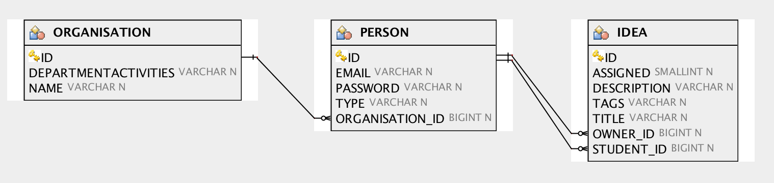

Figure 1: Entity Relationships

To summarise, Figure 1 illustrates the following relationships;

* A Person can belong to one Organisation
* A Person can own many ideas; an Idea has a single Person owner
* An Idea can be assigned to a single student

## System Architecture

As stated in the requirements specification, the new system was built following the MVC design pattern to improve scalability. Following the MVC pattern also enforces the separation of concerns which also improves maintainability and reusability.

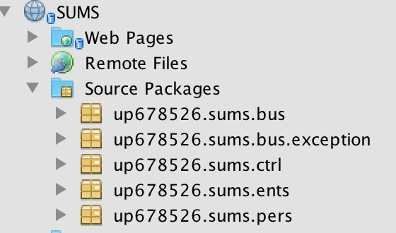

Figure 2: Structure of the application, following the MVC design pattern

As shown in Figure 2, the implementation of this project has been split into five components;

* 1. Entity classes which represent the business objects
  2. Façade classes which interact with the database
  3. Business classes (Session Beans) which contain business functions
  4. Controllers (Managed Beans) which expose data to the view and handles user interactions
  5. JavaServer Faces (Facelets) which represent the views

The interaction between the components of the project follows the interactions illustrated in Figure 3. As the diagram illustrates, the user interacts with the views. The controller’s serve data to the views and also capture user interactions. A user’s interaction can invoke a business task, which is handled within the business classes. If any of the business tasks result in the manipulation of the database, the business class will invoke the appropriate methods of the façade (persistent) classes. All database manipulation is conducted within the façade classes, which only the business classes interact with.



Figure 3: Java EE Implementation Architecture (<http://briggs.myweb.port.ac.uk/WEBP/notes/servlets/singleServer.gif>)

## User Interface

The user interface designs are presented in the user interaction design document. The designs were create using Balsamiq, an online rapid wire-framing design tool. The designs were altered from the originals to incorporate more functionality into each view, which reduced the number of pages the user had to navigate. It is hoped that providing more functionality on the same page improves usability of the application.

The interfaces were implemented using BootsFaces (<http://www.bootsfaces.net/)>, a JSF Framework that combines Bootstrap 3 and jQuery UI. Using BootsFaces significantly expedited and improved the front-end design implementation. Furthermore, BootsFaces incorporates Bootstrap’s fluid grid layout, which results in responsive design meaning the layout will dynamically adjust based on the screen size.

# Implementation and Testing

## Technologies and Development Tools

|  |  |
| --- | --- |
| Technology / Development Tool | Ease of use |
| NetBeans 8.1 | Having previous experience in using Eclipse, adjusting to NetBeans integrated development environment was easy due to it’s similarity with Eclipse. Only subtle differences such as were keyboard shortcuts needed to be learned. |
| GlassFish Server 4.1.1 | Many of the errors encountered throughout development were caused by the GlassFish Server. One of the most common error encountered was one regarding ‘No Active Contexts’. After a while, it was found that simply rebuilding and redeploying the application would solve this issue.  Another error encountered was regarding the ‘Managed Beans’ being unreachable, and therefore resolved to ‘null’. Only after significant debugging it was found that restarting the GlassFish server or restarting NetBeans would solve this issue.   Another problem regularly encountered was regarding the Java Database not reflecting the properties declared within the entity classes. This occurred when a property was edited or added to an entity. At first, it was thought setting the ‘Table Generation Strategy’ to ‘Drop and Create’ would solve this error. However, this approach did not always solve the problem. The solution was to delete the tables from the Java Database and then redeploy the application. This caused all tabled to be created with the updated properties. |
| BootsFaces | BootsFaces significantly eased the creation of the views while improving the overall look of the application. Utilising the BootsFaces (Bootstrap) meant that minimal time was spent developing CSS rules to style the application, as the Bootstrap CSS stylesheet was used. BootsFaces was also simple to learn as there are many supporting materials online (Massera, 2013). |
| Git & GitHub | Git and GitHub was utilised for version control. Due to previous experience, there was no learning curve involved in using these technologies. The main benefit of using Git and GitHub in this project was the reassurance that the code is backed-up in a repository. Also, the reassurance of knowing previous versions could be returned to should there be a need to revert any changes. |

## Search Functionality

The table of ideas is implemented using BootsFaces ‘DataTable’ tag. The DataTable is populated with all available ideas in the database. BootsFaces DataTable provides inbuilt search and paging functionality. The user can even specify how many ideas they wish to view at a time. The search functionality within the DataTable is effective because the user can search the table of ideas instantly, and without having to refresh the page. The only drawback is that there is request for every available idea within the database each time the table needs populating.

## Security Implementation

A security system was required for the project so that only authorised users can access and interact with specific parts of a website. For example, in the context of this application, students should only be authorised to view and select ideas whereas staff members can view, create, edit and delete ideas.

The aim was to implement ‘container managed security’, however despite numerous attempts, this was unable to be implemented. Problems were encountered when attempting to configure the GlassFish security realm and mapping the security roles and constraints within the *web.xml* file. As an alternative, ‘application managed security’ was implemented instead. This meant that within every restricted business method, a check for whether the current user is authorised to execute the method was required. This was acceptable for this project as there were relatively few business methods, however, for larger and more complex this may become less manageable. The benefits of application-managed security are that it provides greater control and means that the security technique can be fine-tuned for performance (Briggs, n.d).

The approach taken in this project means that staff member specific views are not restricted, meaning a student could access the staff member views by manually typing in the URL. For example, a student could access the view that edits an idea. However, as the business methods are restricted, a student will not be able to actually update the idea.

## testing

Testing was conducted with the use of Selenium IDE (<http://www.seleniumhq.org/projects/ide/>), a plugin for Mozilla Firefox that provides functionality to record and automate user-interface tests. Replaying these tests ensure that no errors are introduced when any changes are made to the program. Figure 4 shows an example of a ‘Login’ test case.

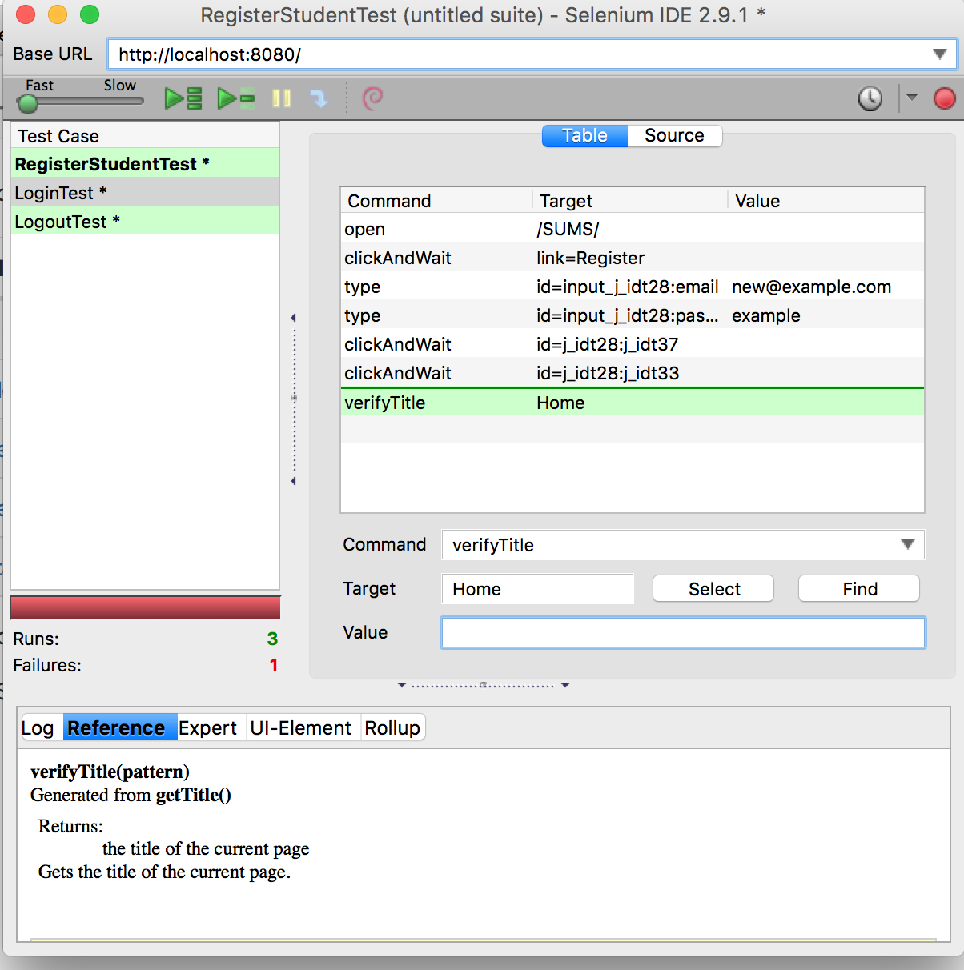

Figure 4: Selenium IDE showing LoginTest

It was originally hoped that unit tests could be implemented using NetBeans and JUnit. However, many problems occurred when trying to configure and resolve the ‘EJBContainer’ for the test classes.

# Summary

The project meets all of the requirements specified in the original version of the requirements specification. In fact, during the implementation of the project the requirements specification was extended to provide even more functionality. It can be stated that the project meets all of the requirements defined in the requirements specification.

One of the most successful design decisions was the decision to use BootsFaces, which greatly expedited and improved the font-end design of the system. BootsFaces made it simple to implement an attractive, responsive design. Specifically, BootsFaces provided simple method of outputting error messages to the user, to improve usability.

The main aspect of the system to be improved is the security mechanism. The implemented mechanism means that users can still view specific pages that they are not authorised to interact with. A better approach would involve restricting the views themselves such that users cannot view pages that they are not authorised to interact with.

A second area of improvement would be to provide more effective way of assigning tags to ideas. The original aim was to develop a Tag entity that has a many-to-many relationship with an Idea entity. However, due to time constraints this was unable to be implemented. As a result, the system simply stores tags for each idea as a string. The problem this introduces is that when searching for multiple tags, the search will look for tags that matching that specific order. The solution would be, to as originally planned, store tags as separate Tag entities.

# References

*An introduction for potential clients*. Retrieved March 17, 2016, from <http://www.sums.port.ac.uk/pdb/projects/ideas/2006/letter.htm>

Briggs, J. (n.d.). *Securing web applications using java ee* [PowerPoint slides]. Retrieved from <http://briggs.myweb.port.ac.uk/WEBP/notes/servlets/security.htm>

Goncalves, A. (2013). *Beginning java EE 7*. United States: APress.

Heffelfinger, D. R. (2015). *Java EE 7 development with NetBeans 8*. United Kingdom: Packt Publishing.

Massera, R. (2013). *BootsFaces: The next-gen JSF framework based on Bootstrap*. Retrieved from <http://showcase.bootsfaces.net/>